**Information**

|  |  |  |
| --- | --- | --- |
| **CRIM ID** | **Title** | **Workstream** |
| C0722 | Remove memory option on the Tunstall Access Details custom LU– v0.1 | Service Management |

**Revision History**

|  |  |  |  |
| --- | --- | --- | --- |
| **Revision** | **Date** | **By** | **Remarks** |
| 0.1 | 13/07/2021 | Erika Sukevic | Base spec |
| 1.0 |  |  |  |
| 1.1 |  |  |  |
| 1.2 |  |  |  |

# CRIM Narrative

We have a custom LU on the Service Request screen called Tunstall Access Details.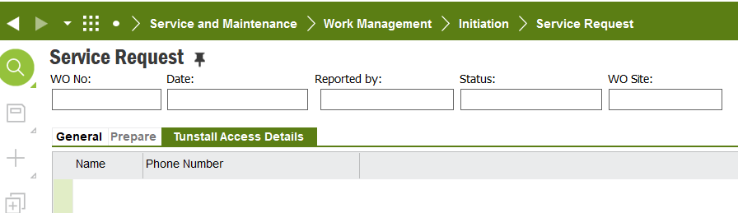

Currently what the CRIM does is if the access detail line was created on one work order then every time the new work order is created against the same object ID these access details are being copied over to the new work order as well.

We need to remove this functionality and only have Access Details saved against the work order it has been created without copying it anywhere else.

**Delivery Notes**

ACP: EA_SERVICES

Modification is done to the custom tab ‘cpgContactDetail’ by adding WO_NO as a parent key.

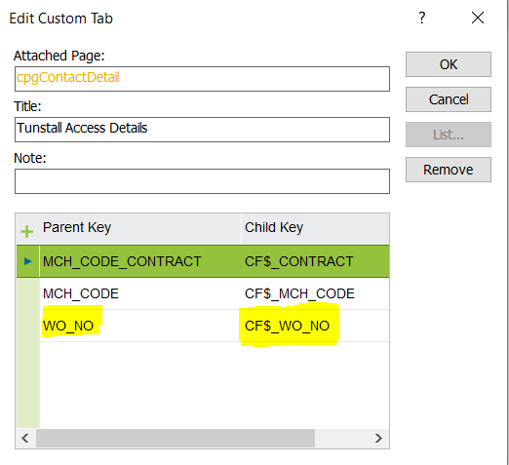

Related custom LU is added via ‘mobile_wo_additional’.

Please reload the configuration by RMB on ‘Service Request’ Header after importing the ACP.